**Technology**

Uber’s data is assembled in a [Hadoop data lake](https://www.dezyre.com/article/data-lake-vs-data-warehouse-is-the-warehouse-going-under-the-lake/283) and it makes use of  [spark and Hadoop](https://www.dezyre.com/article/hadoop-vs-spark-not-mutually-exclusive-but-better-together/235) to process the data. Uber’s data comes from a range of data types and databases like SOA database tables, schema less data stores and the event messaging system, Apache Kafka.

Uber is insatiate about the data it collects and with many cheap relative storage options like Hadoop and Spark-it has got data about every single GPS point for every trip taken on Uber.

Big data analysis covers diverse functions at Uber from machine learning, data science, marketing to fraud detection and many more. Uber’s data contains information about trips, billing, health of the infrastructure and other services behind its app. The overall process of data streaming for Uber is done via Hadoop Hive based analytics platform which gives right information to people with the services they asked for with required data at right time.

Python is the exclusive data science programming language which is vastly used by the Uber data team. Third party modules such as NumPy, SciPy, Matplotlib and Pandas are used to conduct Data Science at Uber, data team also put in use R programming language, Octave or MATLAB at times for prototypes or one-off data science projects. D3 is the most preferred data visualization tool at Uber and Postgres is the most preferred SQL framework.

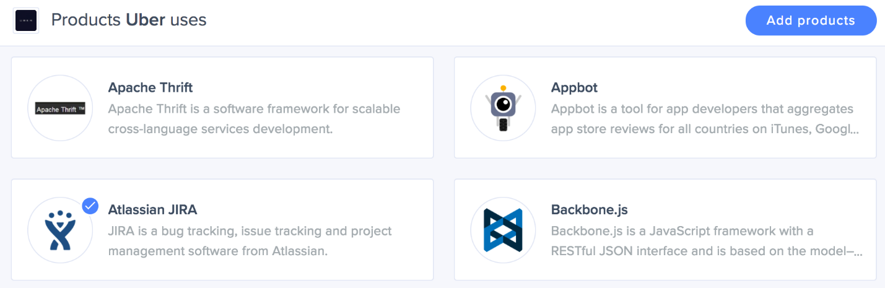

Ref:  <https://stack.g2.com/company/uber>

Here are the tools that [Siftery](https://siftery.com/company/uber" \t "_blank) has identified being used at Uber. The data is collected by Siftery and verified by vendors and employees at Uber.

* **Marketing:** Sprinklr, TweetDeck, Rafflecopter, NUVI
* **Sales and Support:** Streak, Zendesk, Sparkcentral, Delighted
* **Developer and IT:** Atlassian JIRA, Twilio, Redis, Cisco Jasper
* **Analytics:** Mixpanel, Heap, Optimizely, Yahoo! Analytics
* **HR:** AngelList Jobs, Hired, Recruitby, Staff Finder
* **Finance:** Braintree Payments, Expensify, PayPal, Square
* **Productivity:** Asana, HipChat, Assistant[.](http://assistant.to/)to, Zoom

<https://stack.g2.com/company/uber>